How to add hyperlink

1. After created bug ticket, add bug ticket number into Excel sheet in column “Bug ticket number”

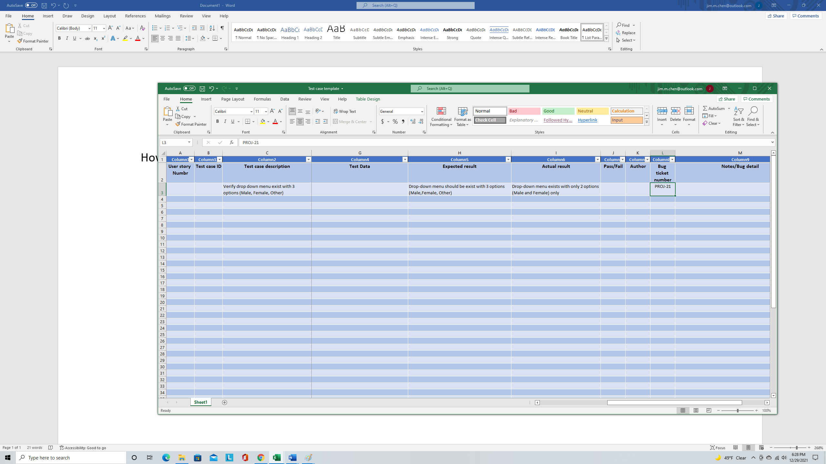

1. Right click on your mouse and then click on “Link"

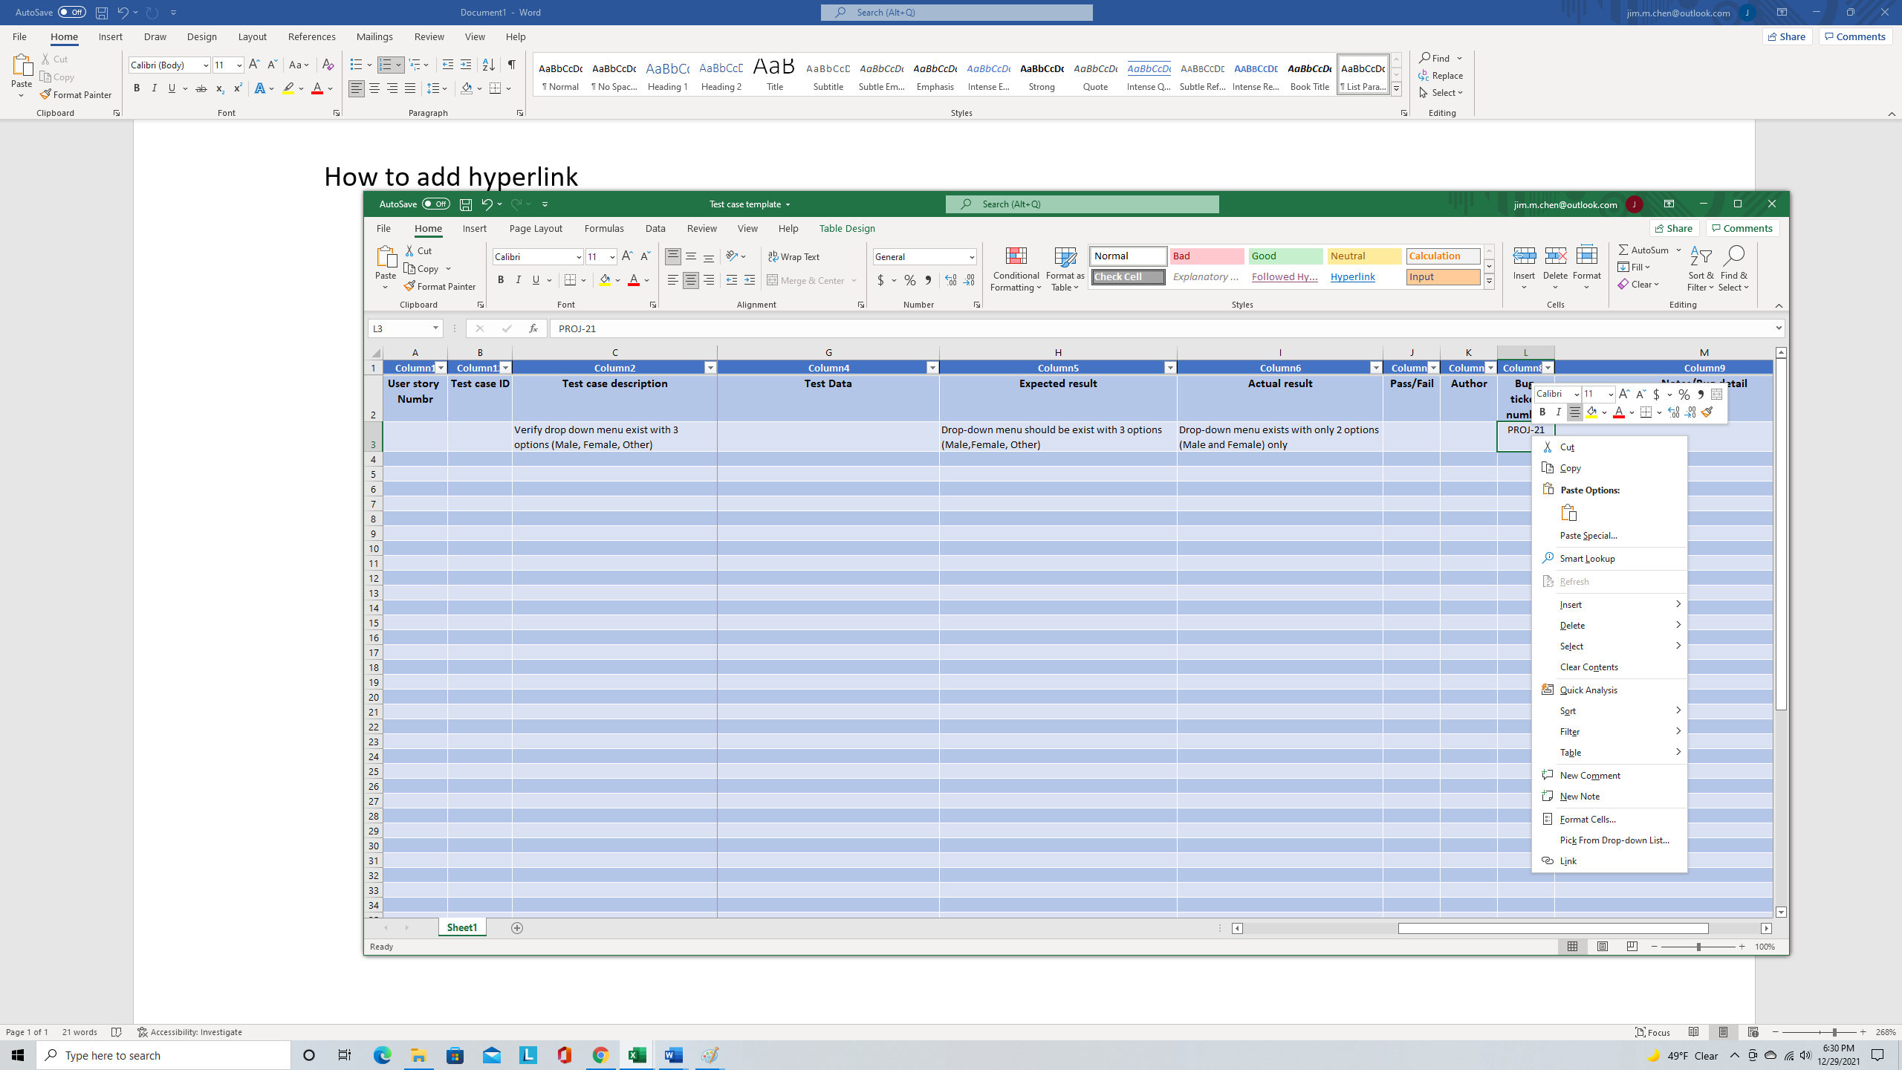

1. Link screen will be appeared

3.1 Enter bug ticket number in “Text to display” field

3.1

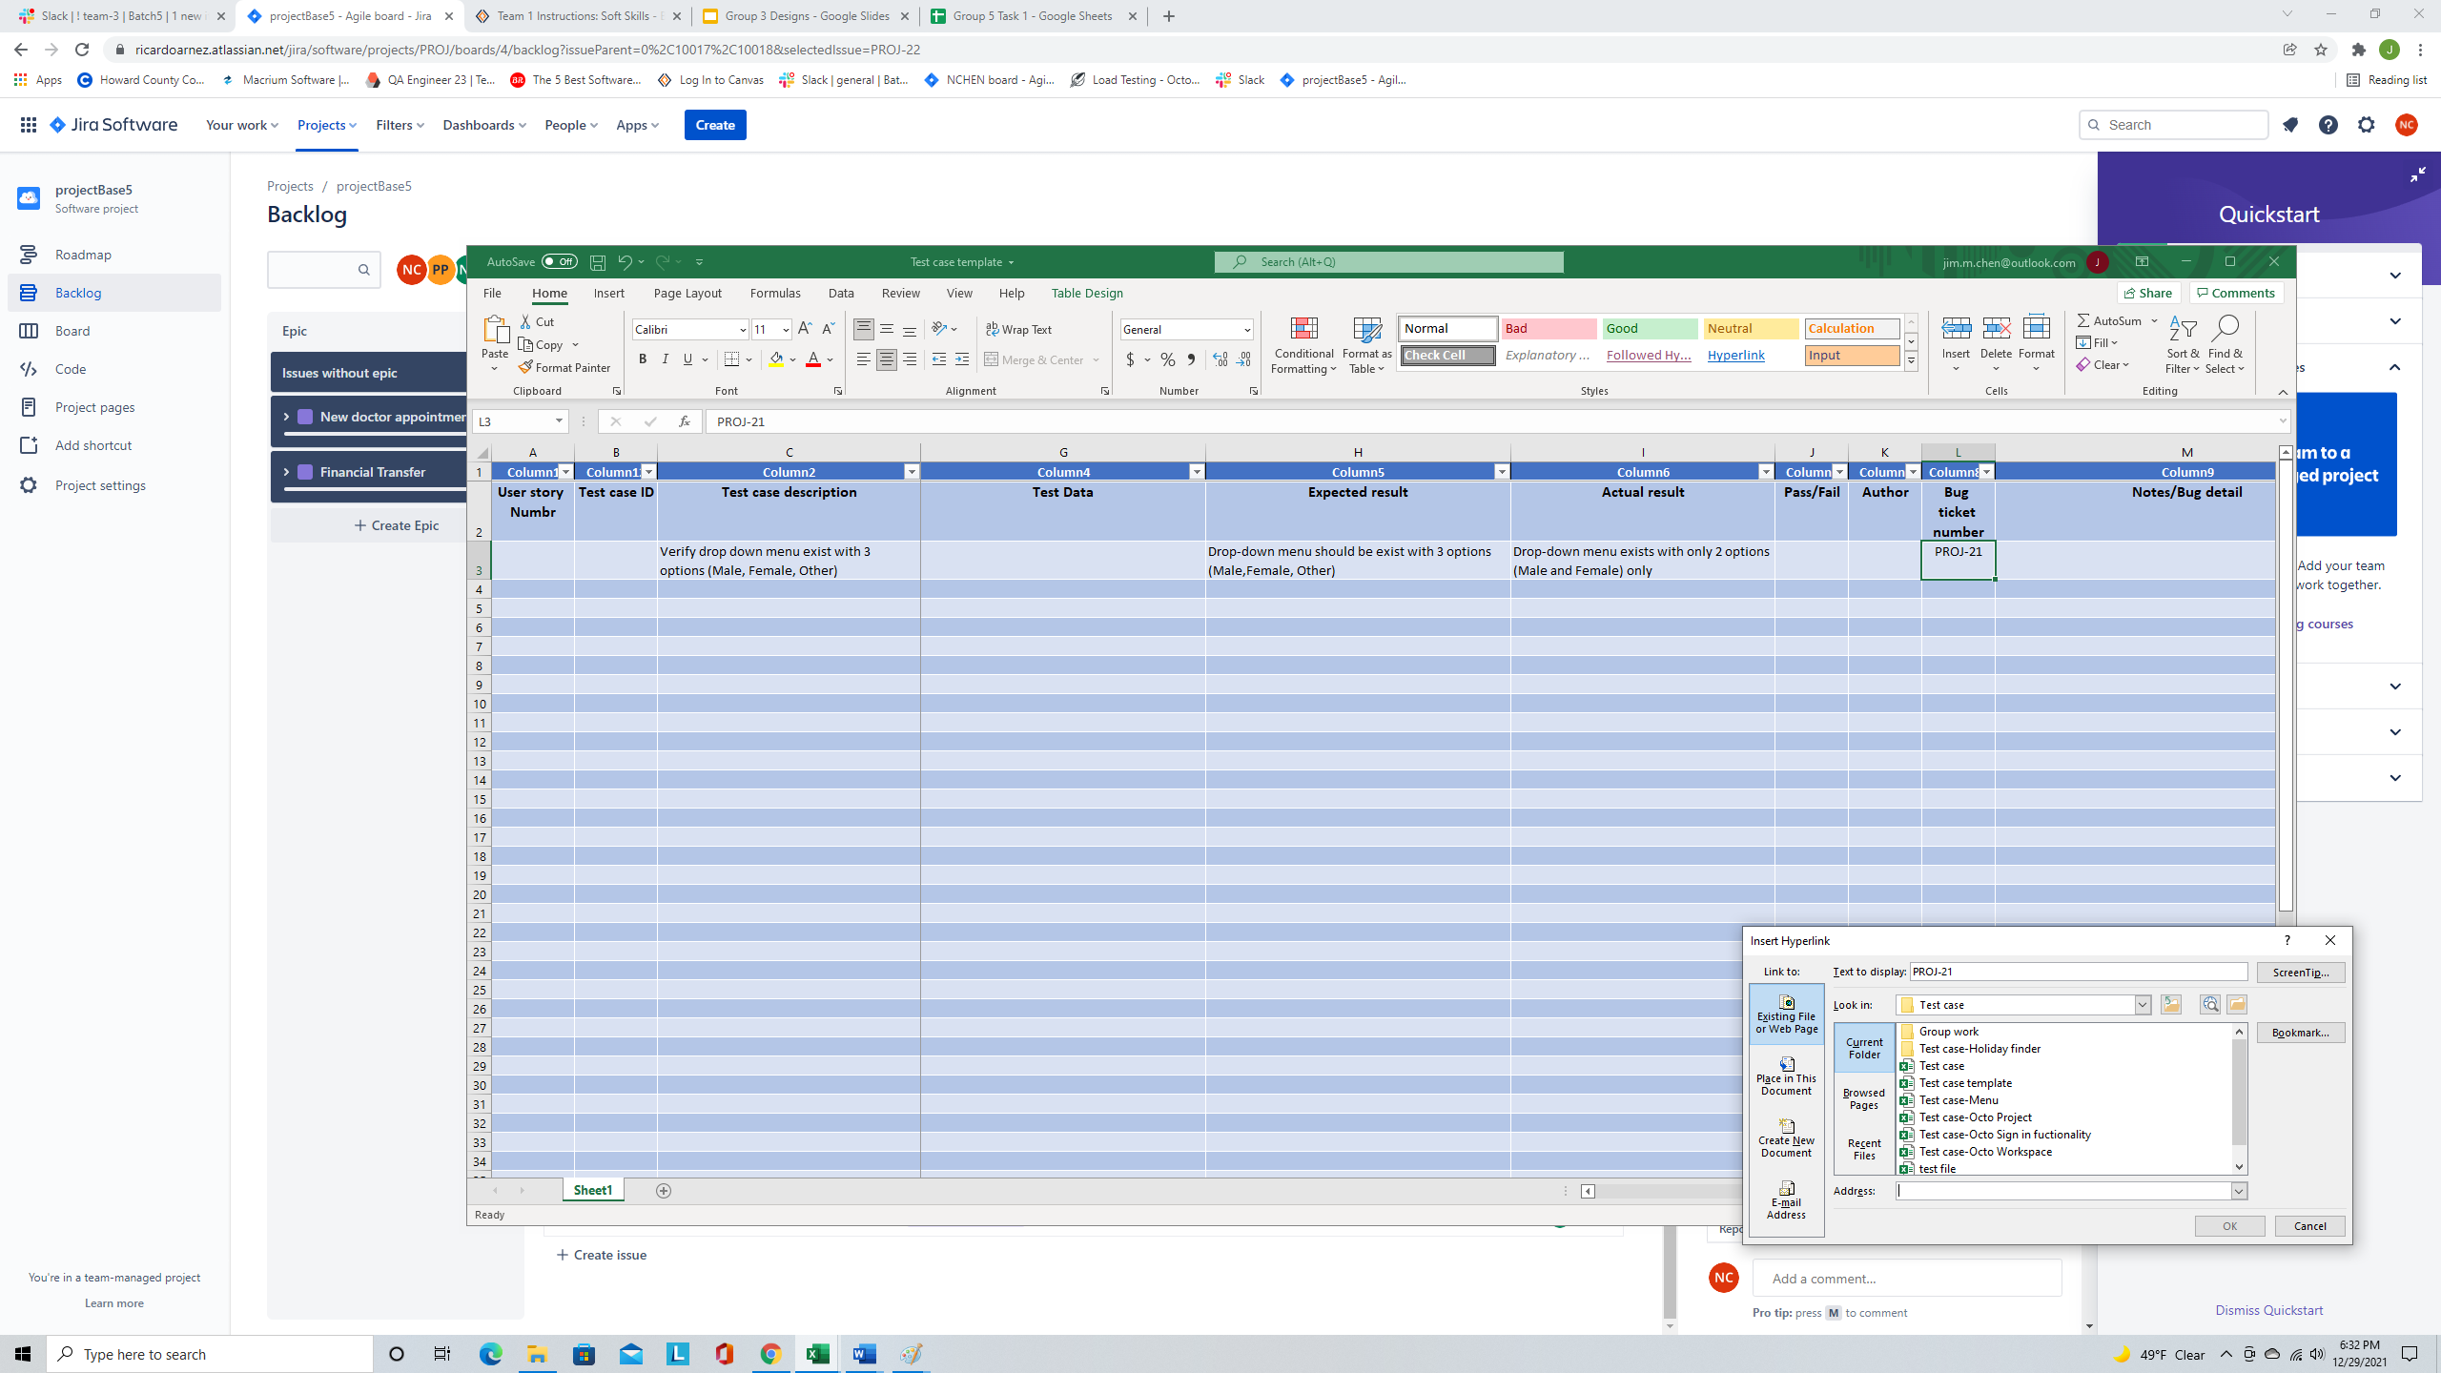

Follow in below step

3.2 In order to get a bug ticket link, please follow this step.

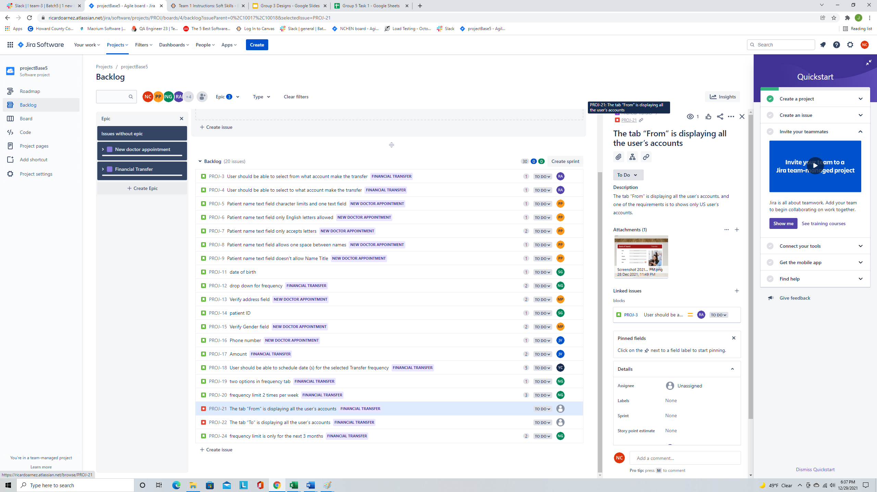

2. Bug ticket tab

2. Click on bug number

1. Click on bug ticket

1. Copy link and plate in “Address” field as No.4

And then bug ticket will be displayed in another tab.

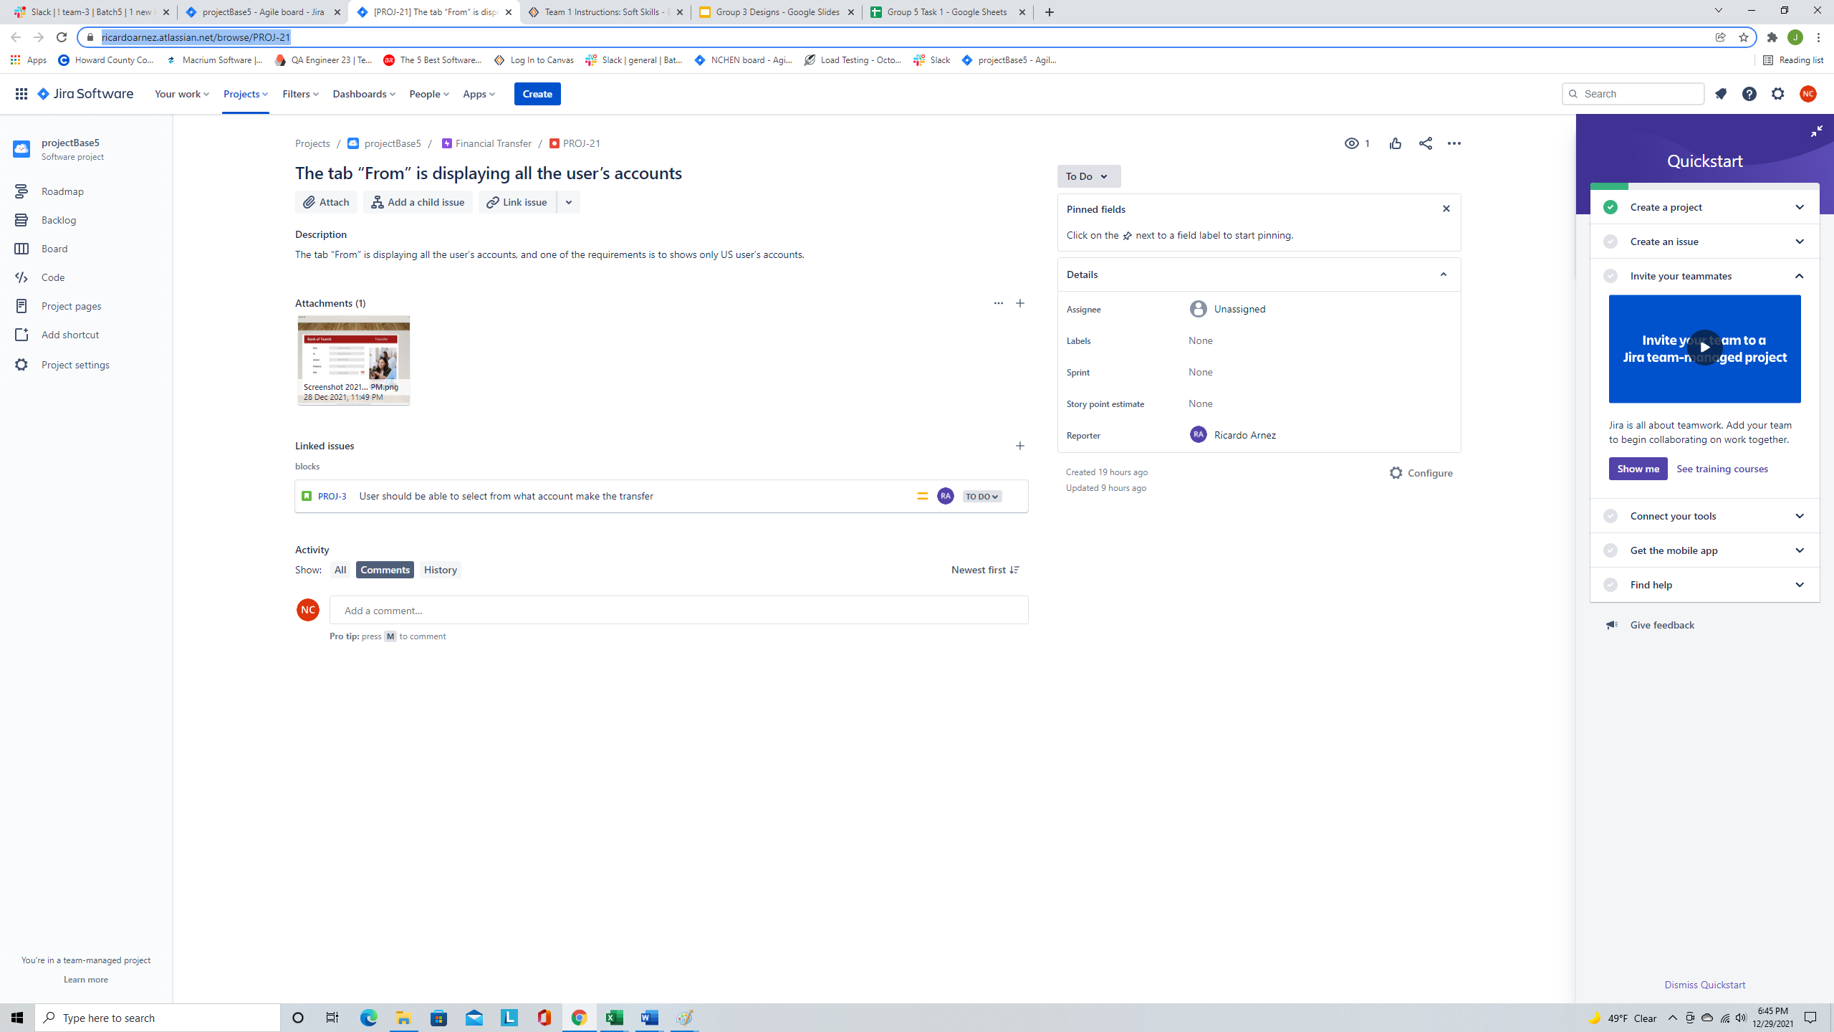

1. Copy link and plate in the “Address” field and then click ok.

